3D-dimensional Effective Stress Analysis of Wetting and Wetting Trapping Process in Wet-submerged Loess Tunnel Surrounding Rock Based on BP Neural Network
Wen Wang^{1,}
¹ College of Geological Engineering and Geomatics Chang'an University, Xi'an 710061, Shaanxi, China
Abstract

INTRODUCTION: China's loess is vast. Loess has apparent high strength and resistance to deformation once encountered with water immersion and humidification, fusible salts precipitated on the surface of soil particles, the soil's carry alkalization strength is relatively reduced, while the vertical tubular pores in the soil accelerate the infiltration of water, the earth will be in the self-weight or the overlying loads of the additional action of the soil body will produce a significant settlement deformation, which results in the structural damage of the upper building, which is the loss of the wetting of subsidence.
OBJECTIVES: From China's practical point of view, the humidification and wetting process of wetted loess tunnel peripheral rock is deeply discussed and analyzed, and the water content distribution characteristics of wetted loess tunnel peripheral rock are sought.
METHODS: Using the particle swarm algorithm, four neural optimization network models, namely, radial basis neural network (RBFNN), generalized regression neural network (GRNN), wavelet neural network (WNN), and fuzzy neural network (FNN), are simulated and created for the analysis of three-dimensional effective stresses in the process of humidity and wetness subsidence in the surrounding rock of loess tunnels of a northwestern city in China and a central city in China.
RESULTS: By analyzing the comparison graphs between the predicted and actual values of these four models on the test data of two sets of experimental data, the distribution of the proportion of the expected difference to the true value, and the results of the calculation of the three error indexes, it can be found that when using the four neural networks, namely, RBFNN, GRNN, WNN, and FNN, for the analysis of the three-dimensional effective stresses during the process of increasing wetting and wetting of the surrounding rock of the tunnel in the soil-wetted loess, the prediction performance of the WNN is the best.
CONCLUSION: The soil's unsaturated settlement characteristics differ for different water contents and humidification times. The shorter the period, the more the soil column water content difference. With the continuous increase of water content change in the soil layer, the distribution of water content change in the loess soil column tends to be relatively uniform, and the difference in damage rate between the upper and lower layers tends to be reduced—the amount, time, and pressure of humidification controls wet subsidence.
Keywords: wet-submerged loess, humidification-wet-submergence process, BP neural network, three-dimensional effective stress analysis
Received on 28 March 2023, accepted on 15 September 2023, published on 26 September 2023

Copyright © 2023 Wang, licensed to EAI. This open-access article is distributed under the terms of the CC BY-NC-SA 4.0, which permits copying, redistributing, remixing, transforming, and building upon the material in any medium so long as the original work is properly cited.

doi: 10.4108/ew.3988

1. Introduction
Loess is widely distributed, accounting for about 9.3% of the total area. Under the low humidity condition of the natural environment, loess has apparent high strength and resistance to deformation. After impregnation, soluble salts released from the surface of soil particles dissolve, soil shear strength decreases, and vertical tubular pores in the soil accelerate water infiltration. Under additional self-weight or overload, the soil body is subjected to significant sedimentary deformation, which causes structural damage to the superstructure， which is why the earth can fold. With the development of urban rail transit, wet underground buildings are imminent. Therefore, it is necessary to clarify the collapse mechanism and the extent of soil collapse to avoid damage to tunnels and other structures [1]. The southern trunk line of the Luohanzi II project is about 170 km long, of which about 35 km passes through the hilly plateau and Gao Bao plateau and the northern trunk line passes through the Weibei area of He and Wei I, Tiantai II, and Huangling plateau. The total length is 112 kilometers. Therefore, about 1.4% of the Wei II project is in the wet absorbent loess layer. The baseline can be formed at the II-IV level, significantly impacting the project design [2].
Evaluating underground roadway folds and soil treatment methods are central and complex areas of current Löss mechanics and engineering research. Currently, the evaluation and treatment of folds are carried out by the national standards for folding fire extinguishers building codes, mainly for buildings that need to withstand high overloads, such as industrial and civil building bases, and focus on the basic concept of "maximum folds," due to the saturation of shallow loess. However, tunnel construction is characterized by a small excavation volume, a small footprint, and no additional overload pressure. If the construction work is carried out according to this specification, it may lead to unreasonable technical planning. At the same time, given the unique characteristics of the tunnel bottom structure, a more rational approach should be sought to assess collapsibility and develop more reasonable geotechnical treatment principles, aiming to evaluate the project's "true collapsibility." Based on the burial depth limit of wet deep forest soil, tunnel moist soil's technical characteristics and unstructured conditions are studied to avoid large-scale plowing and save construction costs. For example, in the southern section of Xi'an Metro Line 5 (Yue et al.) and the eastern province of Line 6 (Tianjin Bay-Nanzhou), the degree of collapse and the lower limit of failure were determined in large-scale flooding tests. It was determined that there could be no residual collapse in the lower part of the main structure, which avoided the treatment of folded bases and saved project costs. Therefore, a reasonable evaluation of the degree of collapse of the strata in combination with the actual project site can not only effectively control the construction investment but also has important theoretical and practical significance for similar underground projects [3].
2. Research background
to evaluate the smoothness of soils with different degrees of flexure and take appropriate measures to eliminate the folds of grounds. Such an assessment method must align with reality, and overdevelopment increases economic investments. The interchangeability of soils is calculated based on the soil moisture [4]. Therefore, studying corrosion geology is essential for quantitatively evaluating corrosion dispersion, strength, and technical drainage. In the past, research on soil filtration could have been more timely due to the availability of test equipment in the back of China. Foreign research on permeability is still in its infancy, mainly focusing on theoretical and laboratory studies. Richards first extended Darcy's theorem to the unsaturated percolation zone and obtained Richard's equation, similar to Darcy's law applicable to unsaturated percolation. Newman first combined finite element theory with unsaturated percolation equations to study saturated and unsaturated problems under complex boundary conditions. Fredlund systematically studied gas phase and water flow in unsaturated soils [5].
In the 1950s and 1990s, saturated and unsaturated research in China focused on theoretical analysis of filtration mechanisms and internal tests of filtration properties. Typical hypothetical research results are the studies by Dongsheng Liu, Zonghao Zhang, and Ying Liu on the effects of different types, structures, densities, initial moisture, and fine-grained permeability of unsaturated soils. Radiality and Yunfeng Li analyzed the impact of pore neck and pore distribution morphology on permeability [6]. The tests included in-house and in situ tests. Chen Zhenhan et al. studied the evolution of soil filtration extraction under triaxial conditions and the effect of different indoor test methods on water and gas transport patterns in unsaturated soils for the Heihe Dam loess condensation [7]. A series of simple sampling devices for obtaining both horizontal and vertical soil samples were developed by Yao et al. Based on theoretical analysis and indoor tests, the unsaturation and permeability coefficients of soil samples were determined by the soil layer test method, reconstructed soil samples with different dry densities were established, and the effect of dry density on the unsaturation coefficient was compared [8].
Compared with the indoor test, the field underwater-to-ground test is less perturbed, and the filtration limit and spatial and temporal variation of the volumetric water content can be obtained to provide a basis for the analysis of the infiltration pattern of loess. It has the advantage that internal tests cannot be replaced [9]. At the beginning of the diver field test, the water volume can only be measured by instruments such as borehole or Loyola because the test equipment is available in the back, so there are disadvantages of delay and small sampling volume. It could not adequately prove the subsurface seepage and could not accurately record the seepage time at different depths. With the development of the TDR water level test technique, a significant breakthrough was made in studying the water transfer pattern of Löss subsoil [10]. By pre-drilling and manually exploring TDR moisture meters located at different locations and depths inside and outside the test pit, the dynamics of the change in the volumetric water content of the gauges during seepage was observed to estimate the seepage time and soil saturation. The horizontal penetration distance was calculated from different points of the same horizontal line, and the vertical critical penetration depth was estimated from other vertical locations [11]. The volumetric water content was measured, and the required depth was determined at the southern bank of the Yellow River in Taiping, Lanzhou, with the Yellow Snow Mountain and four terraces. The water penetration rate was 22.5.25 m fast. Meanwhile, the volumetric moisture change curve measured by TDR measures the spatial and temporal distribution of volumetric moisture and influences the occurrence, deformation, and moisture change [12]. However, the placement level of the hygrometer in the field dive test was only 11 m with a high arrangement distance, so the infiltration level and humidity influence range could not be obtained. Liu et al. conducted many soil infiltration experiments in the Xinshan section of Jiulong Creek and showed that the TDR technique can continuously control the soil water content. During infiltration, the saturation increased linearly with time, and the maximum crumbling at the same depth occurred at the beginning of the infiltration. The drawback of this study is that the TRD moisture meter was buried at a depth of 2.5. 2.5M to determine the soil moisture content below the surface water table indoors using the Loyola shovel sampling method. Since then, many studies related to submergence tests are still being conducted. The materials and references from this study were also used in a series of extensive submergence tests conducted in Qinzhou and Lanzhou provinces of Shanxi [13].
3. Research methods and basic theory
3.1 Basic theory
3.1.1 BP Neural network
The artificial neural network does not need to determine the mathematical equations of the input-output mapping relationship in advance, only because people need to be able to learn some other basic mathematical rules systematically through the training of their brain in advance when people input the value of the input function given to people to set expectations to finally get one of the most easily close to the value of the output value of the role assigned to people to set expectations in mathematical results. An artificial neural network system is one of the computer's operational processing systems for intelligent information, and one of its central core functions is the training algorithm [14]. As an essential part of modern artificial intelligence, BP neural network technology has powerful nonlinear display and parallel information processing capabilities. It has been widely used for model identification, data classification, and functional adaptation. As shown in Figure 1.
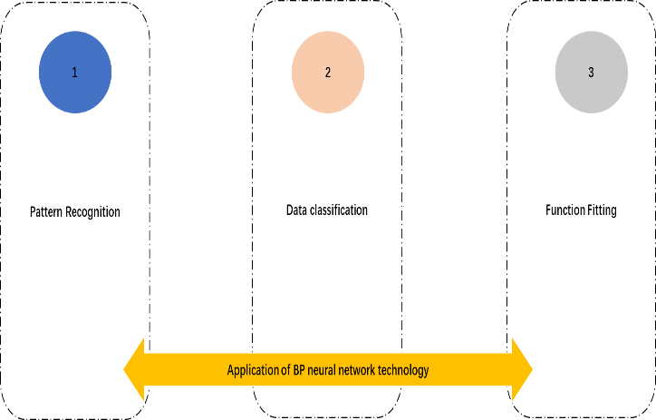
Figure 1 BP neural network technology application
Callant et al. demonstrated that if the working result on the network is infinitely close to the actual value, then there is no limit to the number of training samples. However, collecting a large amount of data to model neural networks takes much work. The problem of modeling BP small neural networks is an excellent concern for domestic and foreign scholars. To solve the small problem, Juerding et al. [integrated expert experience into the simulation process so that the learning results of neural networks in minor conditions are similar to those in a large number of samples, but this method is only applicable to the input and output of one-dimensional models, but this method can only optimize the initial values and thresholds and does not allow the root to solve minor sample prediction problems. Honggang Wang et al. proposed to extend the training samples with the Bootstrap method and Latin American hypercube kernel density scanning method and prepare neural network BP with the extended pieces, which solved the problem of simulating neural networks with BP small data samples and verified the applicability of Bootstrap method. However, this method can only be applied to small practice systems. Wenqing Zhao et al. developed a BP parasitic neural network as a module to improve the learning accuracy within the BP small neural network by overlaying multiple modules, but this method needs to be simplified. The principle of BP neural networks is to continuously adjust the weights and thresholds throughout the network using backpropagation (direct, direct, and reverse) to reduce the sum of squares of errors. The output value is set to be close to the expected output value [15]. The neural network BP model consists of an input, hidden, and output layer, as shown in Figure 2.
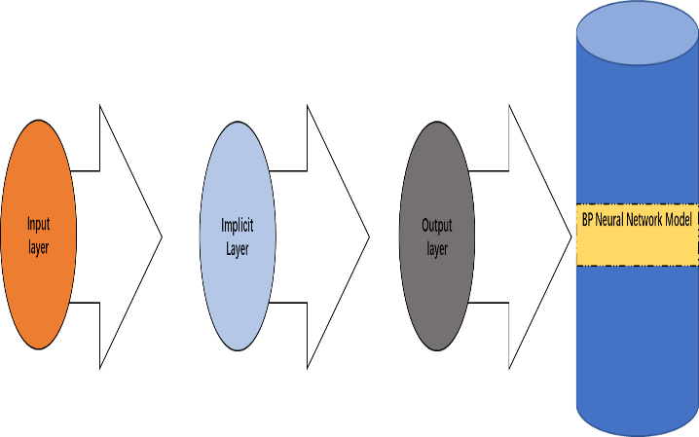
Figure 2BP neural network model composition
Figure 3 shows the structure of the BP single hidden neural network; when building a BP neural network, the number of hidden layers significantly impacts the detection speed, and currently, there is no stable option for the number of hidden layers. If too many layers are hidden, the training time will increase, the model will become complex, and the efficiency will decrease. As shown in Figure 3.
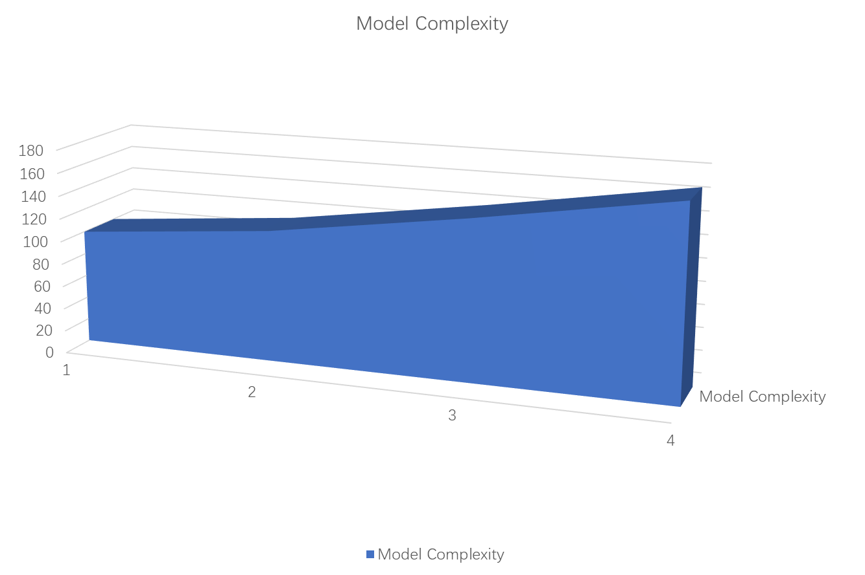
Figure 3 Relationship between model complexity and training time
The number of hidden layers must be more significant to reflect the complex mapping. To solve these problems, this paper uses a BP single-layer neural network to increase the number of hidden layer nodes [16]. For the input of Jan-Fermel inverse spectral coefficients, 12-dimensional MEL inverse spectral coefficients are selected as input layer nodes, the number of hidden layer nodes is 10, and the output is an acoustic beacon with one output layer node. The AB software established a three-layer BP neural network structure 12101, as shown in Figure 4.
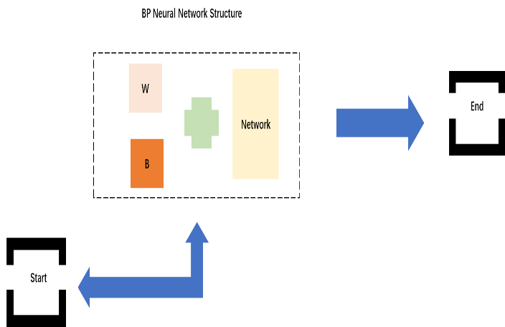
Figure 4 BP neural network structure
3.1.2 Discussion of loess wetting mechanism
Previously, due to undeveloped technology, people could only look at it from the outside. During this period, various opinions have been expressed, including the capillary hypothesis, soluble salt hypothesis, compaction hypothesis, etc. These views only partially reflect the cause of the collapse. A microscopic understanding of soil structure has been gained through binoculars, scanning electron microscopy, electron microscopy, and computed tomography. Wang Yongyang, Lei Xiangyi, and others pointed out that the shape of the soil skeleton particles, the size of the porosity in the soil, and the form of bonding between cement materials and soil particles determine the technical properties of the earth. In contrast, wet, depressed woodland soils lose stability in the soil pore space due to their unique structural system and undergo water urination. Therefore, water humidification is also a process of solidification and compression [17]. In terms of wet seepage mechanism, the causes of soil seepage can be divided into two categories: the first is the unique structural system of wet-absorbing loess, and the second is the influence of external forces such as force and water. Seepage is the leading cause of soil collapse. In the case of low soil moisture, folded loess soil can maintain high compressive strength. However, water will weaken the adhesion between particles, replace soil particles, lead to skeleton deformation, and eventually lead to soil settlement. The degree of crumbling depends on the structural strength of the natural mortar. If the external load exceeds the soil's power, the structure maintains its self-sustaining stabilizing ability and cannot be destroyed after applying moisture. The critical value of the stage is called the initial crumbling pressure; if the external load exceeds the strength of the structure itself and the maximum deformation occurs after water immersion, the critical load at this stage is called the maximum crumbling pressure. In general, the influence of external loads and moisture is determined by the soil structure itself, and the degree of landslide depends on the characteristic value of the landslide pressure. In this regard, the possibility of loess depletion should be evaluated according to specific technical and field conditions, and possible future changes in the structure should be accurately predicted. [18]
3.2 Research methods
(1) The function of the penalty function method is to transform the constrained optimization problem into an obstacle-free optimization problem. The main task of the penalty function method is to determine the sentence length and initial penalty coefficients, and according to the sentence form, the penalty function method is divided into the static penalty function method, the dynamic penalty function method, and the self-reward function method. The penalty coefficients applied by the self-reward function method can be adjusted according to the optimization process. The self-reward form can change the penalty function in time according to the feedback after optimization, which has certain advantages compared with other penalty functions. It is assumed that there are constrained (MI-GE) and CI (GE) problems, which must satisfy ≤ 0. The penalty function converges slowly and can easily lead to unexpected issues if the penalty factor is too significant [19].
(2) The expression of expert knowledge means that the experts in the field have some understanding of the research mechanism. Expert knowledge also becomes empirical, institutional, and domain knowledge. Call. "A posteriori" and other enterprises define prior information as follows: A priori information is the relationship between information input and output, known from experience before model building. This paper focuses on the monotonicity of expert knowledge, which is mathematically defined as follows :using monotonicity as specialist knowledge. In terms of monotonicity relations, the monotonicity of the original data obtained by training the neural network model can be evaluated. Suppose the actual mathematical relations become increasingly monotonous (contraction), and the learning results in the neural network become increasingly bland (decline). In that case, the expert's knowledge is consistent with the learning process and will not be penalized. The penalty is imposed if the verdict contradicts the actual value. According to the Lagrangian day space, the update of the multiplier A is meaningful only when the optimization objective is restricted to a locally convex structure and the Lagrande function converges in time. The Lagrangian multiplier space method effectively overcomes the drawbacks of these two methods.
(3) the BP neural network can usually evaluate whether the root-mean-square error between the initial and actual values matches a given accuracy, thus determining whether learning should be stopped. If the accuracy does not meet the requirement, the weights and thresholds of the BP neural network are adjusted by decreasing the gradient to minimize the root mean square error. In this paper, the Lagrangian function is extended as the objective function of the neural BP network so that the results of the neural BP network satisfy the root-mean-square error and expert knowledge. It is assumed that the monotonicity of specialist expertise is a monotonic recurrence relationship between input five and output G. The premise is that the general method of the extended optimization solution method is used to restrict the Lagrange multiplier method
(4) BP is a dynamic neural network with feedback and memory functions. To better adapt to the communication channel estimation in the Offdm system, the input and output layers contain two neurons corresponding to the real and imaginary parts of the input and output signals. The neural network uses a stochastic gradient descent function with MSE or activation function for the loss and activation functions and a tangential function. The genetic Algorithm is one of the methods used to optimize the optimal 3I group space search to prevent the initial weights from being generated randomly in the BP neural network, effectively preventing the BP neural network from entering the local area network. The specific steps to implement the genetic Algorithm are listed belo —data normalization The amount of data for practical applications is significant, and metrics differ between different input data To avoid prediction errors associated with data inputs, the data inputs must first be streamlined Ibukahla et al. pointed out that artificial neural networks (ANN) are an effective means to solve complex problems in image and signal processing Ibukahla et al. used BP methods to simulate the nonlinear characteristics of satellite communication channels and concluded that neural networks have good data matching capability In recent years, more and more scholars have used deep learning to evaluate channels Soltani et al. used super-resolution methods to estimate channels and introduced DNCNN into the network to eliminate noise This approach further complicates the situation Because it relies on image corruption, it has worse readability Zhang suggested using a BP neural algorithm to determine the channel impulse (CIR), and the result is very close to the actual Cir. Mei et al. achieved global optimization by randomly distributing weights and thresholds. Population intelligence algorithms that optimize the structure of neural networks are widely used to solve this problem, but finding the optimal solution is very difficult. This optimization algorithm is easy to detect in the early stages of convergence with low accuracy. GoldenSine (GSA) Tanyildizietal. The Algorithm has small parameters, fast convergence, good robustness, and high practicality.
Considering the sensitivity of neural BP networks to initial values and thresholds, this paper proposes to determine the BP neural network weights and points using the GSA algorithm and optimize them as a separate unit of the GSA algorithm. The individual fitness function, which is the root mean square error between features and expected features, determines the optimal weights and threshold levels. The next step of the Algorithm is creating a network model. The implicit layers of input neurons, output neurons L, and neurons J of network I are defined. The GSA algorithm as a whole is initialized according to the equation, and the combination of weights n and thresholds is obtained as the GSA algorithm, i.e., The dimensionality in the GSA algorithm is a linear combination of weights and points in the network, as shown in Eq.
X, a, and b in the above equation all denote the variable factor weights.
4. Research results and discussion
4.1 Experimental environment and parameter settings
The dynamic and effective stress analysis method can reasonably consider the interaction between the soil skeleton and the pore water medium and the changes in soil mechanical properties during the site liquefaction process. If the pore fluid drainage channel is blocked during the dynamic loading process, the skeleton curve of the same skeleton model, i.e., the pore fluid drainage channel blockage, can be predicted. The relationship is shown in Figure 5.
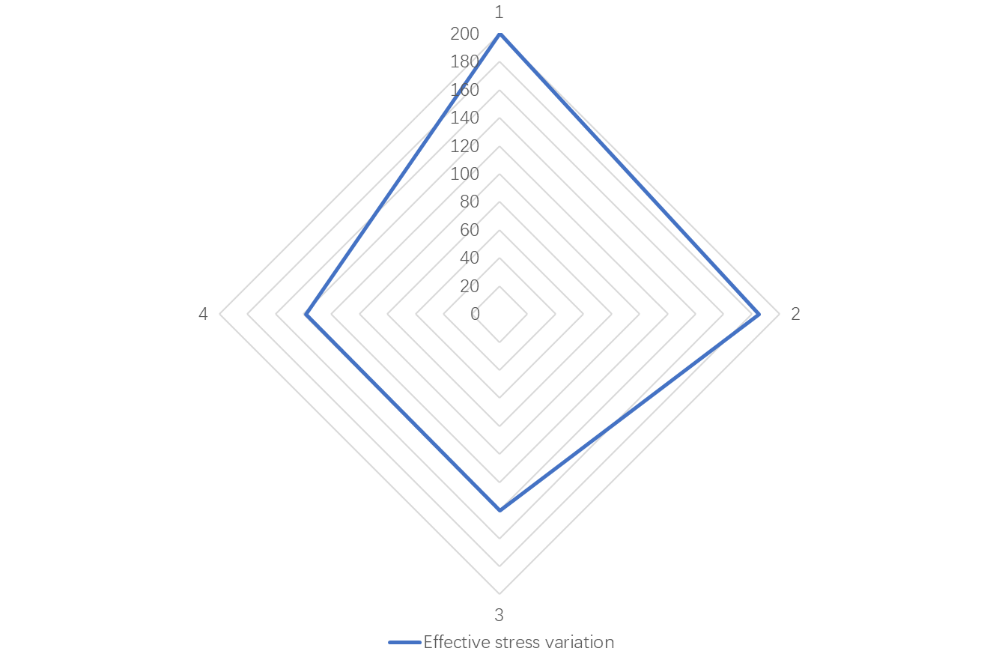
Figure 5 Effect of shear modulus on effective stress
Based on the improved BP network deformation growth model and the volumetric deformation increment model proposed by the authors, the growth of saturated fine sand in the pore water pressure and stress paths was predicted for different cyclic loading patterns. The hollow cylindrical GDS (HCA) device was used for axial torsion, and unprepared cyclic load tests were conducted with an initial ultimate pressure of 100 kPa, load trajectory control to ensure continuous rotation of the central stress axis, and varying the average stress deviation, shear stress and total deviation of both stress combinations in cyclic mode with an initial shear modulus G = 50 MPa, Poisson's coefficient 0.3, saturation weight Y.19. 2kN/m2, everyday stress, and shear stress cyclic mode variation, as shown in Figure 6.
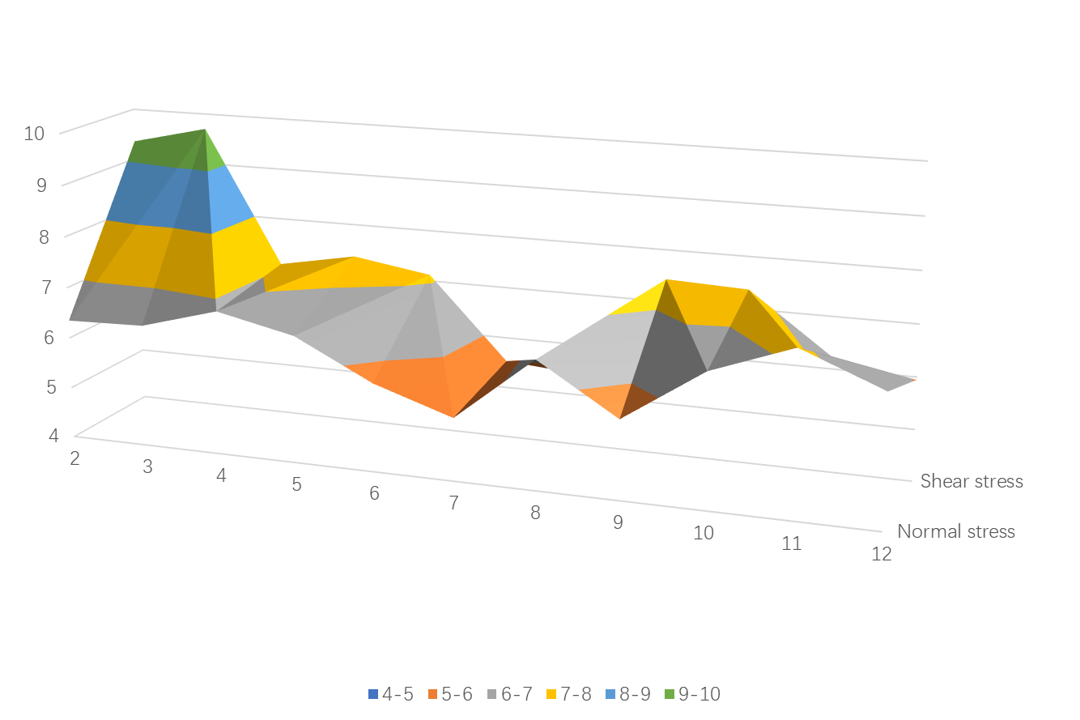
Figure 6 Normal stress and shear stress cyclic mode variation
The development of porous water pressure under one-dimensional stress-shear loops can be well predicted using the modified BP network model. However, the expected results are much lower than the experimental results, and the average pressure difference and stress-shear coupling (i.e., the simulation results are in better agreement with the experimental data reflecting the effect of stress trajectory on aerated water development, which is because the modified Born model is based on the positive-shear test data, and it is difficult to pass the positive-shear relationship Reflecting soil cell overpressure water development law voltage inferno and voltage shear The growth law of pore pressure in saturated sandstone is closely related to the stress trajectory and indifferent The shear test in different bidirectional clutches in the stress path is not consistent, and the shear effect is not uniform It should be noted that the porous state pressure (super porous space pressure fluctuation) increases with the number of cycles, resulting from the increase in structural permeable space pressure caused by the damping of the soil skeleton modulus.
Take the Shatin rectangular tunnel as an example; the overall soil thickness is 60m, the bottom of the tunnel is a waterproof foundation, the tunnel is a three-span structure with a total width of 40m, a horizontal span of 16m, an average span of 8m and a height of 10m The thickness of the upper, lower and side walls is 1m, the tunnel depth is 1m, and the structure is C45 concrete The model uses four nodes with differential strain modulus and a grid size of about 0.25m × 0.25m, and the contact surface of the ground node is rigid contact method. The contact line is the friction method. The standard contact surface stiffness of the ground structure is 7=350gpa. The southern part is shear stiffness. The cutting speed is K.202in's, permeability K.1x10cin's, saturation Y.19.8kN'm3, and critical damping is 5%. The relationship between friction and shear stress is shown in Figure 7.
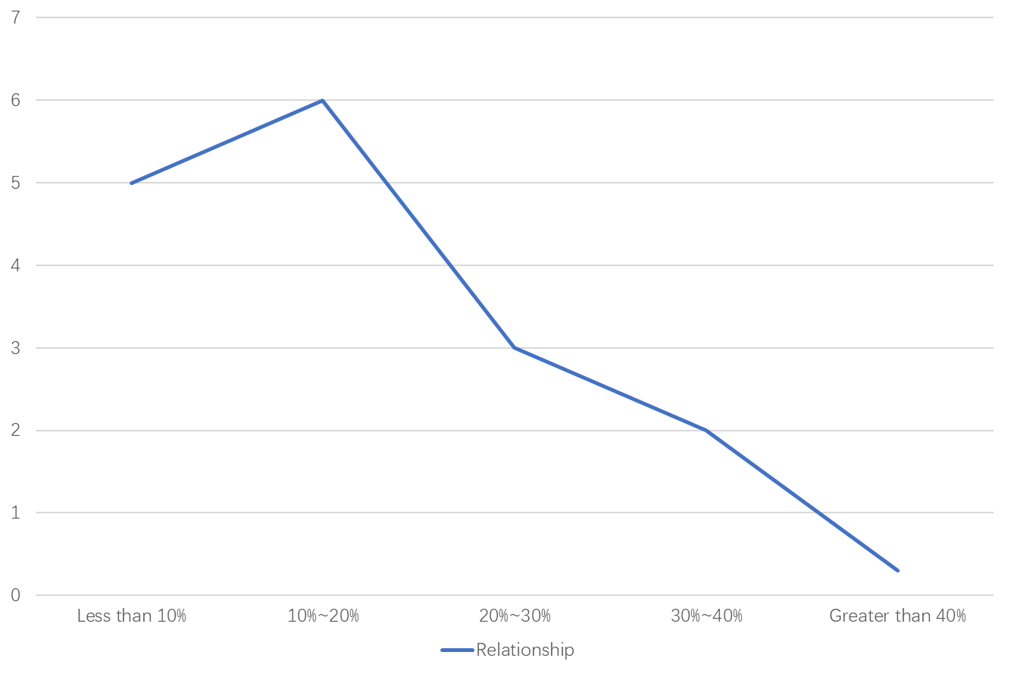
Figure 7 Friction-shear stress relationship
Stress paths of soil elements at different locations The Figure shows that the stress paths in the far field of P(100m) are linear under everyday constant stress and average horizontal shear. The stress paths of the soil elements around the structure vary significantly, showing a continuous variation of average stress deviation and stress shear. The P2 stress path (30 m from the side wall of the form) is ellipsoidally inclined. The diagonal stress trajectory is (3 m from the side wall of the system) This is mainly due to the variation of purely distant stress shear caused by vertical propagation, as well as reflection and transmission during propagation at the contact surface between the soil and the structure, which further complicates the stress state of the soil around the subsurface structure The oblique elliptical and diagonal stress trajectories are formed by their different coupling effects The coupling processes are shown in Figure 8.
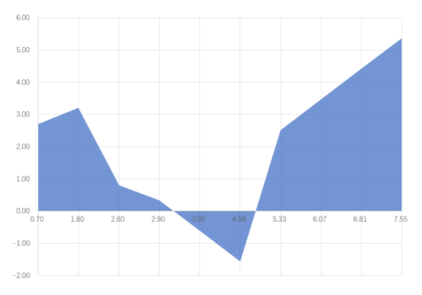
Figure 8 Coupling process
The foundation is divided into "layers" from top to bottom, which gradually change to simulate the whole process of foundation damage Deformation and water seepage from the top of the foundation, and eventually layer by layer, can be assumed to seep out from top to bottom; that is, water seeps out from top to bottom Duncan's tensile model calculates the compression, compression, and primary stress fields in the natural state In this paper, a numerical method is proposed to estimate the crumbling process The calculation sequence is as follows: the upper first layer of soil when saturated (thickness in the unsaturated state, moisture, and saturation at the time of crumbling; and two layers of soil (thickness and foldability in an unsaturated saturated state, when the substrate is saturated by the layer, the fracture conditions of the folded floor slab are calculated using the Mohr-1 Coulomb criterion, and the numerical method is based on three-dimensional finite elements and infinite coupled elements.
The super porous water time curves at different locations around the tunnel structure were compared with the calculated results after adjustment of the BP model. It is shown that the broad field overpressure curves computed using this model and the modified BP model are fundamental. Compared to the modified BP model, a significant extension of the condensation extent is calculated, with liquefaction occurring around the structure, especially in the top layer of the substrate. A substantial concentration of condensation is observed at the corner of the substrate slab, first liquefying the upper and lower slabs. The liquefaction zone gradually expands along the structure's perimeter to form a complete area. The appearance of the tunnel structure changes the nature of the free-field liquefaction, which occurs first at the site surface in areas away from the system and gradually expands. The maximum solidification depth under the tunnel floor calculated from the BP model was 4m, respectively. The solidification depth was the same at 100 m after the 2 p.m. dispersal meeting earthquake, reaching 1.5 m.
The liquefaction performance of the saturated sandstone is closely related to the cyclic load characteristics and stress trajectory The results of cyclic torsional simulation tests on soggy sandstone show that the method describes the hydrodynamic development and liquefaction process of pore-saturated sandstone under complex track stress more reasonably than the modified Berne model developed based on direct cyclic tests The dynamic interaction between soil and subsurface structures causes significant changes in seismic pressures and stress trajectories around the subsurface systems The upward vertical propagation of seismic waves leads to regular vibration of far-field horizontal stress shear, and the ground around the underground structures is in a coupled shear mode with alternating stress shear and standard deviation of stress The improved BP model can predict the dynamic response of the subsurface system over the far-field according to the simulation law of indoor tests but underestimates the accumulation rate of porous water pressure and condensation area around the structure The method can reflect the effect of subsurface structure interaction on the dynamic response of the foundation around the system.
Many studies have shown that the functions mentioned above are difficult to express because some problems arise in soil mechanics, such as unsaturated soils and soil structures, due to the above-mentioned connections However, modern computer technology and equipment have been developed considerably, and the storage location and speed limitations that plagued people no longer exist The response to numerical data allows for the regularity of things, and there is a tendency to replace analytical methods with reflections of complex problems Here, the numerical method is used to reflect the effective stress of the fire extinguisher folding in the destruction process, and the test deformation curve is better than the stress The characteristic points of the deformation curve are directly entered into the computer, and its contents are fixed by three lines of interpolation to form a complete numerical stress on the computer, the elongation curve Its advantage is that it accurately reflects the test results, avoids analysis generalization, is practical and convenient, and is easy for practical application.
4.3 Discussion of the wetting process in the tunnel surrounding the rock of wet-submerged loess
4.3.1 Characteristics of moisture content distribution of wet-submerged loess tunnel surrounding rock
According to the data obtained in the humidification test, the third layer of the soil column in the process of humidification test in different spatial locations of the water content distribution and its curve with the spatial variation of the target time change of the humidification test and its relationship curve When the target water content concentration changes to or greater than 21% in the humidification test, the spatial water content concentration of the first and second layers of the three layers of the loess column and the curve trend changes of their relationship changes are very similar, and all of them can appear a rapid increase or even decrease with the time change of the humidification test target The average water content concentration of the third layer of water is generally the first to start gradually and slowly upward and increase, and after about 3h will gradually start to slowly grow until it drops, and the curve level change is basically close to the level of the first two layers before the end of the test The total water content of the 4th layer of water will gradually and slowly decline upward and increase, and the average water content of the 5th layer of water is generally after about 12h of precipitation will gradually start to slowly downward or gradually slowly increase After 24 hours, the water content in the first three to the fourth three layers will be more or less evenly distributed, with an average of about 20% and - to 21%, respectively, while the water content in the fourth and fifth layers is generally relatively low, at about 19% When the water content change is lower than the target, the total water content of the loess soil column surface will change very unevenly with the fast and slow time When the target water content is reduced to less than 25%, the first layer of water content and the second layer of water content and its trend of change are basically the same, and in the third layer of water content can be slowly and rapidly increase gradually with the rainfall time, more than 6h before a slight and substantial decline in change and began to stabilize evenly The fourth layer on the water content rate change with the second layer of water content rate change rate increases slowly and tends to decrease The water content of the fifth layer will be about 6h after settling that began to to the direction of the upper layer gradually and slowly increase After 24 hours, the water content of the first two or four layers of soil has been distributed basically evenly, concentrated in the water content of 25% to -26%, the water content of the fifth layer began to be lower than the second layer, for 23.5% At this time, the distribution of soil water content in the loess column stratum began to occur from local non-absolute uniform gradually to local uniform direction When the target water content of the soil layer is less than 30% or so on average, the water content of the first floor in the loess soil column will begin to gradually decrease with the rapid increase of settling time, and gradually stop decreasing after 3h time, tending to be more stable The direction of the second and third floors is basically the same.
In summary, after the second layer of the moisture content distribution in the first humidification of 1h and a half time after the moisture content has begun to gradually and slowly decline, six h and a half after the start of the moisture content will tend to essential or close to stabilization, and in the third layer after the moisture content will remain relatively stable The moisture content of the fourth layer began to grow gradually with the time of humidification and progressively grew more slowly; the moisture content of the fifth layer after the humidification and slowly grew faster, 12h and a half after gradually, tends to be relatively stable The test results found that when the target moisture content concentration distribution was about 30% and below, the soil column moisture content began to be gradually distributed and better uniform at least 24 hours after the end of humidification, between about 28% and ~ about 29% level The resultant experimental study also showed that the distribution of water content concentration began to become better and more uniform as the distribution of the target water content concentration for humidification continued to increase steadily.
4.3.2 Evolution and distribution law of unsaturated wetness of soil column
According to the experimentally measured data, the increase and settlement coefficients of the unsaturated zone water content of loess under different horizontal positions on the loess column under the influence of varying water content temperature increase temperature and time temperature increase time conditions were obtained after calculation When the target water content is reduced to about 21% or less, the unsaturated humidification coefficients of the soil column at each position for different times of humidification increase and decrease are changed significantly After six h penetration of the humidified layer, the unsaturated humidification coefficient of the fifth layer also increases gradually and significantly with the reduction of the penetration pressure and the growth of the penetration time, which is closer to the maximum unsaturated humidification coefficient of the fourth layer of water, indicating that the total number of time for the penetration of the water layer to its last layer of water under the action of the unsaturated layer plus humidification coefficient conditions is about 6h One of the essential characteristics of the soil non-total and settlement distribution is that the settlement is not always homogenized.
The test results show that the unsaturated settlement characteristics of soils differ for different water contents and humidification times Humidification moisture content is too low is due to the lower loess soil column moisture content high and low distribution is not very uniform; that is, the upper soil column is tall and moisture content than the lower soil column for high loess structure stress than the lower soil column structure damage is too extensive, so the upper discharge ring specimen structure compression deformation should be much higher than the lower ring knife specimen structure stress is good, and moisture content with the pressure gradually increased, deformation also with the value of moisture content Therefore, there is a significant difference between the wetting coefficient and settlement coefficient of the upper and lower soil structure of the loess column With the continuous increase of the moisture content index of the soil layer, the distribution of the moisture content coefficient of the loess column tends to be closer and closer to uniform. The difference between upper and lower layers of loess structure damage severity gradually decreases, and the difference between upper and lower layers of ring knife deformation severity continues to decline. The average unsaturated loess moisture content index of the loess column in each level is close to each other, and the growth trend is the same.
4.3.3 Soil column overall unsaturated wet sink characteristics
The specimens in different humidity levels of minus plus wet deformation and target moisture content, different relative humidity levels of plus minus plus wet deformation under the premise of the joint influence of time conditions, the loess column in each layer cut ring knife specimens respectively in each of its layers of minus plus minus plus minus wet deformation under the effect of time pressure conditions of superposition (calculated at the high soil column), can be approximated to the specimens in the same loess column layers of minus the overall additive and subtractive humidification deformation, so that the same all ring knife specimens can then be subtracted from the deformation coefficient deformation (calculated at the high soil column) under the influence of additive and subtractive humidification time pressure between its layers, respectively, and need to be combined with the calculation of the original soil column height, respectively, to obtain the unsaturated humidification rate coefficient of the actual soil column height under different abatement and additive and subtractive humidification rate time conditions.
In the above two completely different types of pore moisture content coefficient environment and working time environment changes, with the working pressure coefficient change curve gradually increasing the rate of decline, the pore unsaturated pore moisture content of the surface pores of the loess column will increase sharply and progressively, the growth rate is sharply and accelerated, the curve part will be a reverse dash-like gradual and rapid rise In the lower degree of pore water content conditions, the pore and non-saturated pore water content coefficient of the surface pore of the loess column will gradually increase or slowly rise with the working humidity in the construction time environment and tend to significantly reduce The water content coefficient is maximum when indoor wet plus indoor wet before 1 hour, and the water content coefficient is minimum when dry plus indoor dry and wet after 24 hours When the target moisture content of the test is increased to a level close to 25%, the moisture content index of the non-homogeneous saturated soil on the surface of the soil column may increase gradually with the increase of the test time, compared with the rise in the moisture content of the soil column to 21%, under the influence of various test pressures of different sizes The unsaturated moisture content factor is minimized within 1 hour when the target moisture content value is reduced to only 30% and above and then decreased to the maximum after 24 hours With the gradual and significant increase of the saturated soil moisture content time, the non-uniform soggy soil moisture content time of the soil on the loess soil column will also be further increased significantly with the increase of the saturated moisture content time.
5 Conclusion
In this thesis, based on the BP neural network, a three-dimensional practical stress analysis of wet sediment sedimentary rocks was implemented, and different models were used to simulate the humidification and collapse of loose tunnel sediments The results show that the method can more reasonably describe the hydrodynamic development and liquefaction of saturated sand cracks under complex dynamic stress flow channels than the BP-modified neural network established by single-cycle direct slice tests In addition, the response of the soil around the tunnel in the liquefied ground was further analyzed to explore the interaction mechanism between the liquefied foundation and the subsurface structure The results show that horizontal shear stresses are generated in the far field body under constant everyday stresses during vertical expansion At local propagation to the ground-structure interface, the soil around the structure is in alternating modes of stress-shear and stress-normal deviation increases the accumulation rate of pore pressure and liquefaction area Advanced BP neural networks can predict the far-field dynamic response well, but the accumulation rate cannot expect the far-field emotional response In addition, the process of wetting and wetting trapping of wet-sedimented loess tunnel enclosure is also discussed and studied in depth.
(1) Water content distribution characteristics of wet-submerged loess tunnel envelope After the second layer of water content distribution in the first humidification of 1h and a half time after the water content has begun to gradually and slowly upward decline, six hours and a half after the beginning of the water content will tend to essential or close to stabilization, and after reaching the third layer of water content will remain relatively stable The moisture content of the fourth layer began to increase gradually with the time of humidification and progressively grew more slowly. The moisture content of the fifth layer will also gradually, with the time of humidification. Twelve hours and a half will slowly be relatively stable. The test results found that when the humidified moisture content concentration distribution was about 30% and below, the moisture content of the soil column began to be gradually distributed. Better uniform after at least 24 hours after the end of humidification, between about 28% and ~ about 29% level. The resultant experimental study also showed that as the distribution of humidified moisture content concentration continued to increase steadily, the distribution of moisture content concentration also began to become better and more uniform.
(2) Evolution and distribution of unsaturated wetting in soil column The unsaturated settlement characteristics of the soil under different water content and humidification times are other. The humidification moisture content needs to be higher due to the lower loess column moisture content high and low distribution is not very uniform. That is, the upper soil column is tall and moisture content is higher than the lower soil column, loess structure stress ratio to the lower soil column structure damage is too large, so the upper discharge ring specimen structure compression deformation should be much higher than the lower specimen structure stress is good, and moisture content with pressure gradually increased, deformation also with the moisture content value gradually increased and was Therefore, there are apparent differences in the coefficient of humidification and settlement coefficient between the upper and lower soil structures of the loess column As the moisture content index of the soil layer continues to increase, the distribution of moisture content coefficients of the loess column tends to be closer and closer to uniform, and the difference between the upper and lower layers of the loess structure in terms of damage severity gradually decreases, and the difference between the upper and lower layers in terms of deformation severity continues to decrease The average unsaturated loess moisture content indexes of loess columns at each level are close to each other and have the same growth trend.
(3) Study of the overall unsaturated wetness of the soil column. The shorter the period, the more the difference in water content of the soil column should be considerable. With the continuous increase of water content change of the soil layer, the distribution of water content change of the loess column will be relatively uniform. The difference in damage rate between the upper and lower layers tends to decrease. The overall compression and deformation of the loess column will not only depend on the soil's upper layer but directly on the soil as a whole, and the water content coefficient also increases with the gradual increase of the time factor. The wet linkability is controlled by the amount of humidified water, time, and pressure.

References
- Liu He Yi, Cong Yu, Zhang Li Ming, Zheng Ying Ren, Wang Zai Quan, Abi Erdi, Liu Li Peng Macro and micro failure mechanism of surrounding rock of small span tunnel under different stress paths[J] Journal of Central South University,2022,29(5).
- Yang Zedong,Xu Jiansheng,Feng Qiang,Liu Weiwei,He Peng,Fu Shenggang. Elastoplastic Analytical Solution for the Stress and Deformation of the Surrounding Rock in Cold Region Tunnels Considering the Influence of the Temperature Field[J] International Journal of Geomechanics,2022,22(8).
- Huang Cunhan, Dong Wenhao, Cao Zhengzheng, Wang Yue, An Gangjian, Chen Huanqi, Jia Yunlong, Pan Qiuyu, Shan-Jie Su Water Inrush Mechanism of Fault Zone in Karst Tunnel under Fluid-Solid Coupling Field considering Effective Stress[J] Geofluids,2022,2022.
- Si Xuefeng, Li Xibing, Gong Fengqiang, Huang Linqi, Liu Xiling Experimental investigation of failure process and characteristics in circular tunnels under different stress states and internal unloading conditions[J] International Journal of Rock Mechanics and Mining Sciences,2022,154.
- Cheng Xuansheng, Xia Lingyu, Hu Lankai, He Peicun, Yang Xinping Mechanical characteristics of diversion and spillway tunnel under high in-situ stress[J] Arabian Journal of Geosciences,2022,15(9).
- Yuan Dong,Zhang Lanbin,Liu Xiaoling,Feng Tao,Zhang Guangze,Xu Zhengxuan,Wang Zhewei,Yi Xiaojuan,Lin Zhiheng,Ren Yang,Zhang Ru,Ren Li. Influence of the Xianshuihe Fault Zone on In-Situ Stress Field of a Deep Tunnel and its Engineering Effect[J] Frontiers in Earth Science,2022.
- Wang Huaning, Song Fei, Zhao Tao, Jiang Mingjing. Solutions for lined circular tunnels sequentially constructed in rheological rock subjected to non-hydrostatic initial stresses[J] European Journal of Environmental and Civil Engineering,2022,26(5).
- Zhong Daning, Chen Jianlin, Zhou Hui, Chen Xiangrong, Jiang Yali, Jia Pengjiao. Study on Progressive Failure of Hard Rock Tunnel After Excavation Under High Stress[J] Advances in Civil Engineering,2022,2022.
- Zhou Zihan, Chen Ziquan, He Chuan, Meng Wei, Wu Fangyin, Kou Hao, Yan Jian In Situ Stress Field along the Axis of Deeply Buried Tunnel in Southwest China Employing the Segmented Single-Borehole Inversion Method[J] International Journal of Geomechanics,2022,22(6).
- Bockmann Benjamin, Dankl L, Kucinskaite G, Kumar A, Timothy J J, Meschke G, Venjakob A J, Schulte T L. Bone tunnel placement influences shear stresses at the coracoid process after coracoclavicular ligament reconstruction: a finite element study and radiological analysis.[J] Archives of orthopedic and trauma surgery,2022.
- Li Hanyuan,Li Xinggao,Yang Yi,Liu Yang,Ma Mingzhe. Structural Stress Characteristics and Joint Deformation of Shield Tunnels Crossing Active Faults[J] Applied Sciences,2022,12(7).
- Cheng Rongshan,Wang Huizhi,Dimitriou Dimitris,Jiang Ziang,Cheng ChengKung,Tsai TsungYuan. Central Femoral Tunnel Placement Can Reduce Stress and Strain Around Bone Tunnels and Graft More than Anteromedial Femoral Tunnel in Anterior Cruciate Ligament Reconstruction.[J] International journal for numerical methods in biomedical engineering,2022,38(5).
- Rotta Loria Alessandro F., Di Donna Alice, Zhang Manlu. Stresses and deformations induced by geothermal operations of energy tunnels[J] Tunnelling and Underground Space Technology incorporating Trenchless Technology Research,2022,124.
- Chen Honghao, Ramandi Hamed Lamei, Craig Peter, Crosky Alan, Saydam Serkan Stress corrosion cracking of cable bolts in tunnels: An in-situ testing approach[J] Tunnelling and Underground Space Technology incorporating Trenchless Technology Research,2022,123.
- Gong Bin, Liang Zhengzhao, Liu Xiangxin Nonlinear deformation and failure characteristics of a horseshoe-shaped tunnel under varying principal stress direction[J] Arabian Journal of Geosciences,2022,15(6).
- Huang Bo, Du Yihan, Zeng Yu, Cao Bing, Zou Yu, Yu Qian Study on Stress Field Distribution during the Construction of a Group of Tunnels Using the Pile–Beam–Arch Method[J] Buildings,2022,12(3).
- Tang Hao, Ji Xiang, Zhang Hongyi, Li Tianbin, Chen Qian Numerical Simulation of Large Compression Deformation Disaster and Supporting Behavior of Deep Buried Soft Rock Tunnel with High In Situ Stress Based on CDEM[J] Advances in Civil Engineering,2022,2022.
- Ma Ke, Chen LiPing, Fang Qian, Hong XueFei. Machine Learning in Conventional Tunnel Deformation in High In Situ Stress Regions[J] Symmetry,2022,14(3).
- Bouaré Hamed,Mesgouez Arnaud,Lefeuve-Mesgouez Gaëlle. Stress and displacement fields around an arbitrary shape tunnel surrounded by a multilayered elastic medium subjected to harmonic waves under plane strain conditions[J] Soil Dynamics and Earthquake Engineering,2022,154.

Corresponding Author. Email: 2018026033@chd.edu.cn

